How to add/edit information on the player page

- When logged into your player page you can add/edit your player information, pay your registration fee, and upload a color picture of your face.

- When you first login in, click on the ‘Modify player info’.
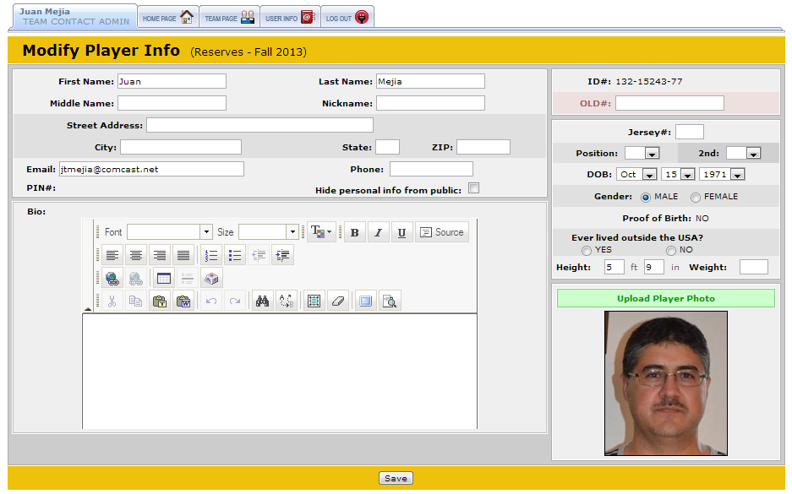
- Make sure the following information is correct as these are used for player cards and roster.
- First and last name
- ID#
- Date of birth
- Email
- An uploaded color photo of your face

- You can add any other additional information if you like but only the 5 in step #3 are required.

- Click ‘save’ if you have made any changes to your player info.

- To pay your registration fee, click on the ‘make a payment link. Fill in the payment information and click ‘continue’ to finish the payment process.

