How to add players players to roster

- Click on the ‘Roster’ link in the green section at the top of the team page.

- The first players you need to add will be any returning players that were on your team from the previous seasons. Click on the ‘Add returning players’ link.
- You can check individual players or all at once. Then click ‘Save’.

- After you have added all your previous players, you can add new players. These are players who have played in the league but not your team or have never played in the league at all.

- You want to search for existing players first. These are any players that have played in the league but not on your team. Once a player has been entered into this website (regardless of team) they will always be searchable. So it is VERY important to search for a player before creating a new one cause we don’t want to create multiple entries for the same person. You can search by name, email, player id # or birthdate. Enter the search info and click ‘search’.

- The search will bring up names matching your criteria. Check the circle to add the player you want and click ‘Save’. If the player has already been added to a team, you won’t have a circle to check. You can also look at the history of the player.

- If the player doesn’t exist, you can create a new player. Click on the ‘Create a NEW player’ link.

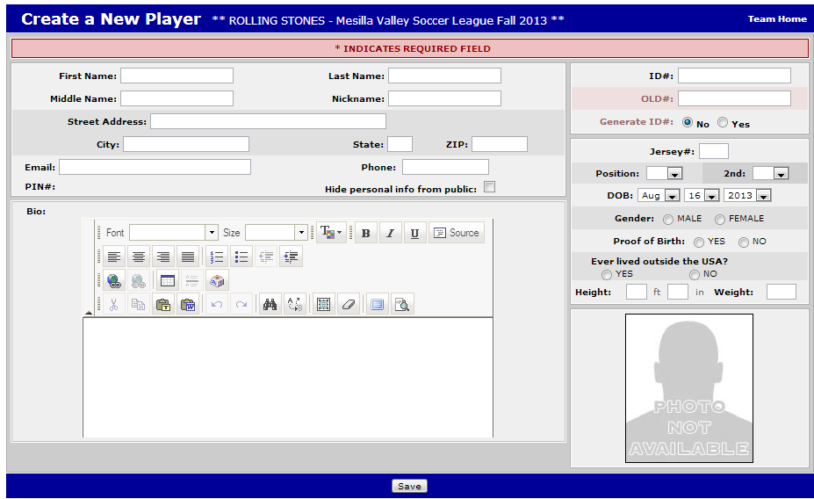
- The information that MUST be entered is first and last name and email. Also, check “yes”circle next to ‘Generate ID #’. Then click ‘Save’.

The rest of the information can be added at a later date either by the team rep or the player. The minimum information is required so the player can login and pay their registration fee by credit card if they like.
Also, the date of birth and a color picture of the players face will need to be added before a player card can be printed. These can be added by either the team rep or the player.

